InsightStream : Navigate the news landscape

1**.Introduction**

InsightStream: Navigate the News Landscape is designed as a powerful platform to simplify this process. It helps users access reliable news, track emerging trends, and gain meaningful insights from diverse sources. By combining intelligent search, real-time updates, and user-friendly navigation, InsightStream empowers readers to stay informed, make data-driven decisions, and explore the news landscape with clarity**.**

**• Project Title:**Insightstream navigate and news landscape

**• Team ID : NM2025TMID44274**

**• Team Leader: Name**: S. Indhumathi

Email.id: [indhumathisubaramani2007@gmail.com](mailto:indhumathisubaramani2007@gmail.com)

• **Team Members**:

Name: J.Kowsika Email id: [kalaiselvi1521982@gmail.com-](mailto:kalaiselvi1521982@gmail.com-)

Name: R . I ndhumathi Email id: indhumathi27708@gmail.com

Name : K.Harini Email id: 12harinikumar@gmail.com

**2. Project Overview**

• Purpose: SB Works connects clients and freelancers through project postings, bidding, and real-time communication.

**• Features**:

– Project posting and bidding

– Secure chat system

– Feedback and review system

– Admin control panel

**3. Architecture**

• Frontend: React.js with Bootstrap and Material UI

• Backend: Node.js and Express.js managing server logic and API endpoints

• Database: MongoDB stores user data, project information, applications, and chat messages

**4. Setup Instructions**

• Prerequisites

– Node.js

– MongoDB 1

– Git

– React.js

– Express.js

– Mongoose

– Visual Studio Code

• Installation Steps:

# Clone the repository git clone

# Install client dependencies cd client npm install

# Install server dependencies cd ../server npm install

**5. Folder Structure**

\___ InsightStream

\___Homearticles.jsx

\___Hero.jsx

\___context

\___Generalcontext.jsx

\___Page

\___Categorypage.jsx

\___Newspage.jsx

\___Style

\___Footer.css

\___Hero.css

**Running the Application**

• Frontend:

cd client

npm start

• Backend:

cd server

npm start

• Access: Visit <http://localhost:3000>

**6. API Documentation**

• User:

– /api/user/npm install

– /api/user/ npm run dev

**• Projects:**

2 – /api/projects/create – /api/projects/:id • Applications: /api/apply

• Chats: – /api/chat/send – /api/chat/:userId

**7. Authentication**

• JWT-based authentication for secure login

• Middleware protects private routes

**8. User Interface**

• Landing Page

• Freelancer Dashboard

• Admin Panel

• Project Details Page

**10. Testing**

• Manual testing during milestones

• Tools: Postman, Chrome Dev Tools

**11. Screenshots or Demo** 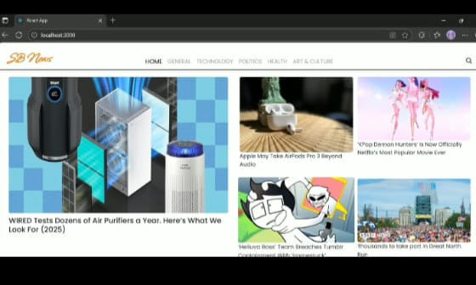

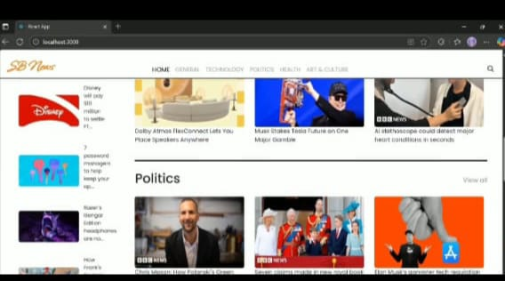

**12. Known Issues**

**13**. **Future Enhancements**